Test results ‘Margin for hitting via points’
I created a small route with a Starting point, Via point (Alerting) and an End point. I did this by first creating Way points, exactly ON the road. Then I created waypoints for the start and via 15 meters (roughly 50 feet) away from the road, and then the same for 30 meters (roughly 100 feet). Only the points named ‘…. spot on’ can be accessed with a bike/car.
The following table shows the combinations:
Route name | Start point name | Via point name | End point name | Starting position tested
Margin spot on | Start spot on | Sportpark spot on | End | Start
Margin Start 15 | Start 15 mtr | Sportpark spot on | End | Start
Margin Start 30 | Start 30 mtr | Sportpark spot on | End | Start
Margin Sport park 15 | Start spot on | Sportpark 15 mtr | End | CEP
Margin Sport park 30 | Start spot on | Sportpark 30 mtr | End | CEP, START
(Note I did not test ‘Margin Sport park 15’ from START, because ‘Margin Sport park 30’ was OK)
Overview of the routes: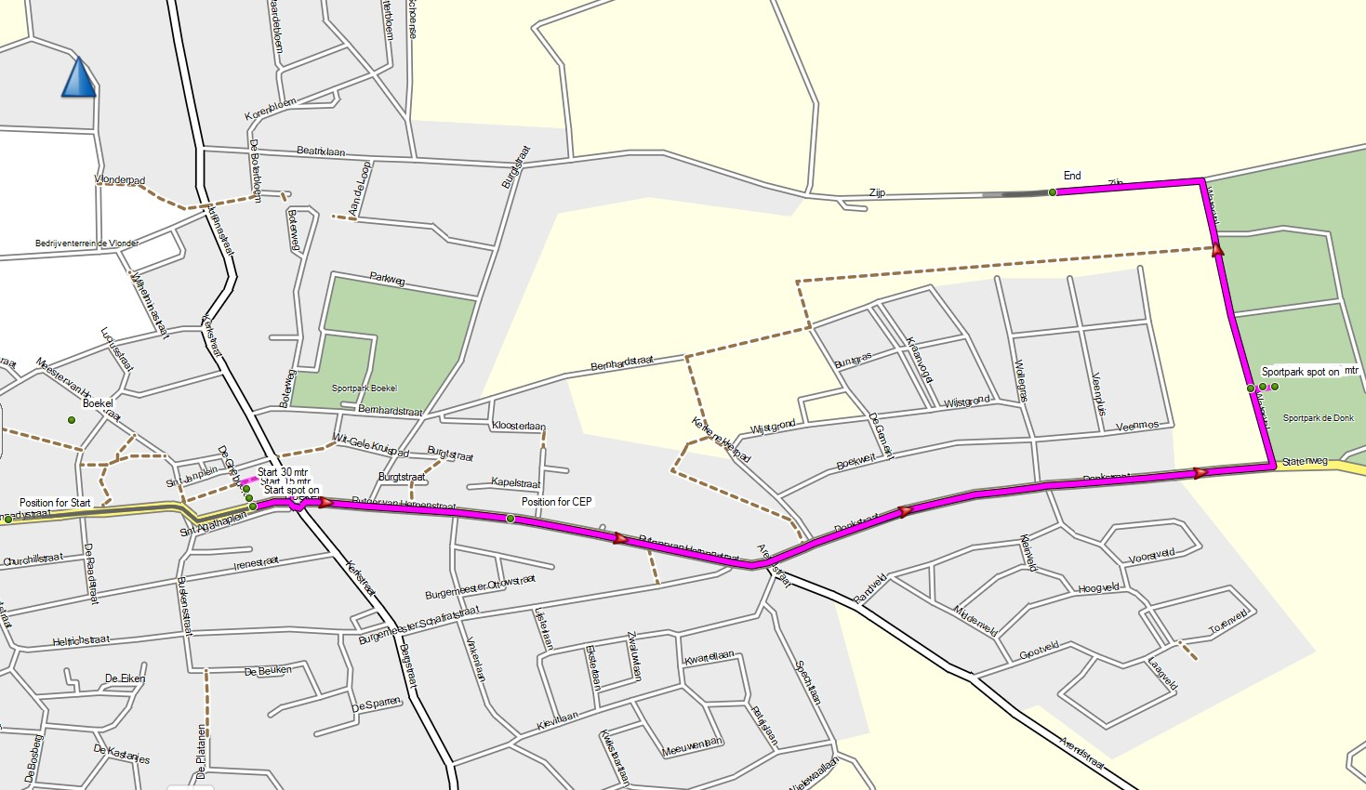
Starting and via points: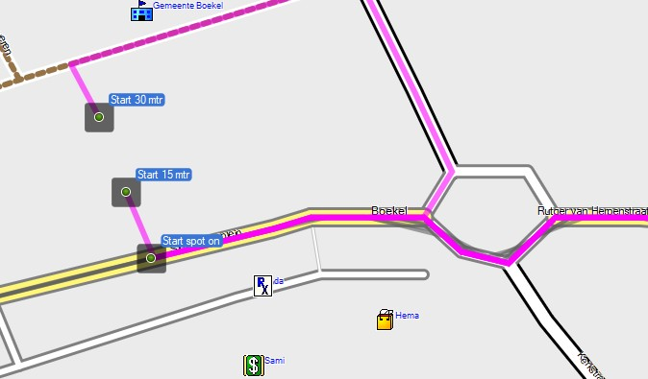 | 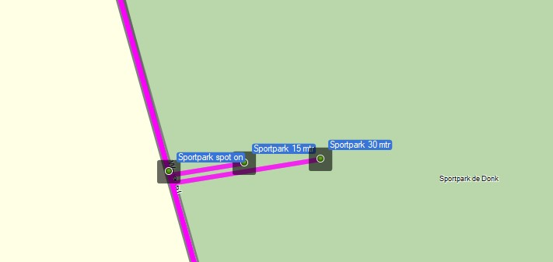

Not anticipated, but interesting. The route ‘Margin Start 30’ is different from the others. Being closer to another road it chooses to head for the roundabout from another direction.
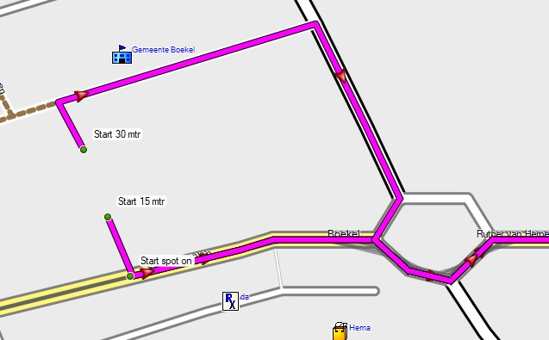
I have used 2 starting positions to start the different routes. 1 used when starting the route from the Start, and 1 for starting the route with Closest Entry Point .
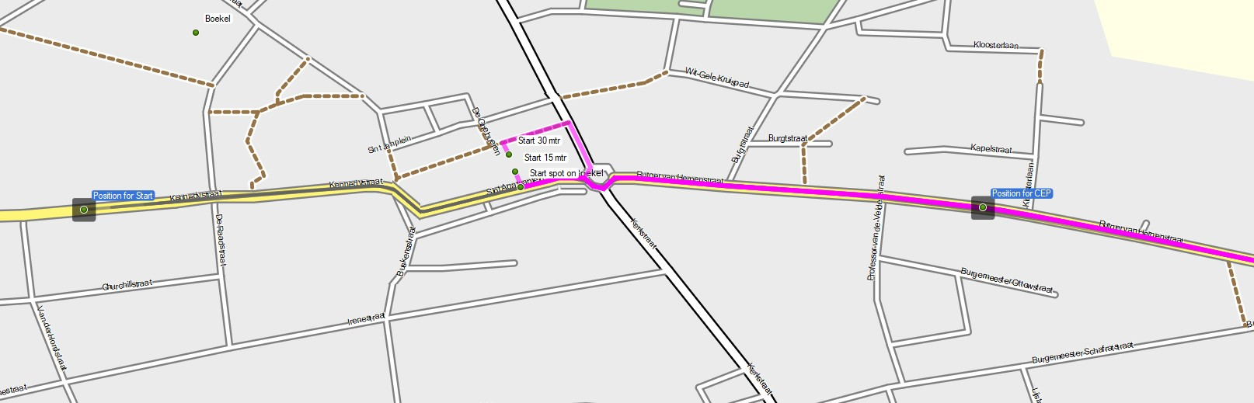
For each test I had the track recorder running. You can find these tracklogs in the GPX file.
Start Spot On | OK
Start 15 Mtr | OK
Start 30 Mtr | OK
Sportpark 15 Mtr Cep | OK
Sportpark 30 Mtr Cep | OK
Sportpark 30 Mtr Start | OK

All test were OK. I had (spoken) directions, the Zumo never asked me to make a U-Turn, or deviate from the planned route.
Conclusion:
The margin for ‘Hitting a Via point’ is a least 30 meters (Roughly 100 feet).
- When used to start the route.
- When used as an intermediate point.
I would like to repeat these tests with a greater margin (50, 100 meters) to see what happens, but for now I’m happy with the results, and to know that 30 meters is accurate enough.

