Summary test result RUT
Date | Description | Result | Remarks
25 Jan | Initial test | RUT | Simple route with 1 via point
26 Jan | Dont skip 1st via | RUT
28 Jan | Shaping instead Via | RUT
5 feb | Trip from Track | RUT
15 Feb | Trip created on XT from Waypoints | NO RUT
18 Feb | Trip created initially on XT (from 15 Feb), transferred to PC, transferred again unmodified to XT. | RUT | Very disappointing. I cant imagine why the result should be any different from 15 Feb
19 Feb | Trip created in Basecamp, with ALL <gpxx:RoutePointExtension> nodes stripped with an XML editor | RUT | This effectively forces a recalc when loading on the Xt.
21 Feb | Garmin Explore | NA | Test not performed.  Intermediate points are ignored.  No Via points to be skipped.
22 Feb | Route and Zumo set to Driving/Car mode. | RUT | For the first time noticed a phantom point. Probably was there with other tests also, but never noticed.

RUT: I got requests to make U-Turns.
NO RUT: Arriving at De Mortel, where following the track would indeed be faster, it would stop requesting U Turns

Zumo is on firmware 6.50
Map is City Navigator NTU 2023.2. Basecamp and Zumo
Routing parameters: Motor Cycling, fastest time, no avoidances, except ‘unpaved’.
Traffic: Disabled
I have kept all Tracklog, screenshots and GPX files.
All GPX files were sent to XT using the Garmin Drive App.
Current.gpx, CurrentTracklog.gpx and Screenshots where copied to PC using USB connection.

General remark:
- It is arguable what behaviour is desirable. You could prefer the RUT behaviour, because keeping the original route is important. On the other hand you could prefer NO RUT, because when it is impossible to continue on the original route you expect the XT to offer you a new route without the need to stop and restart the route.

Conclusions:
- A trip created on the XT behaves differently from trips created on PC and sent to the XT. Why should that be?
- A route sent from PC to XT will never behave as if it was created on the XT. At least I was unable to.
  - The test on 18 Feb made that clear. Transferring a trip created on the XT to PC, and resending that same gpx (unmodified) should produce the same result!
  - That also rules out the possibility to change the behaviour using the subclass field.
- When a route with only via points is sent (19 feb) the XT has to recalculate. No ghost points are available, nor subclasses. Hoping to get the same result as if the trip was created on the Xt. Nope!
- In a RUT scenario, when the XT eventually stops RUT, not the original route is followed, but the fastest route to the next via point. (End point in my case)
All Tests have a route/trip that looks like this:
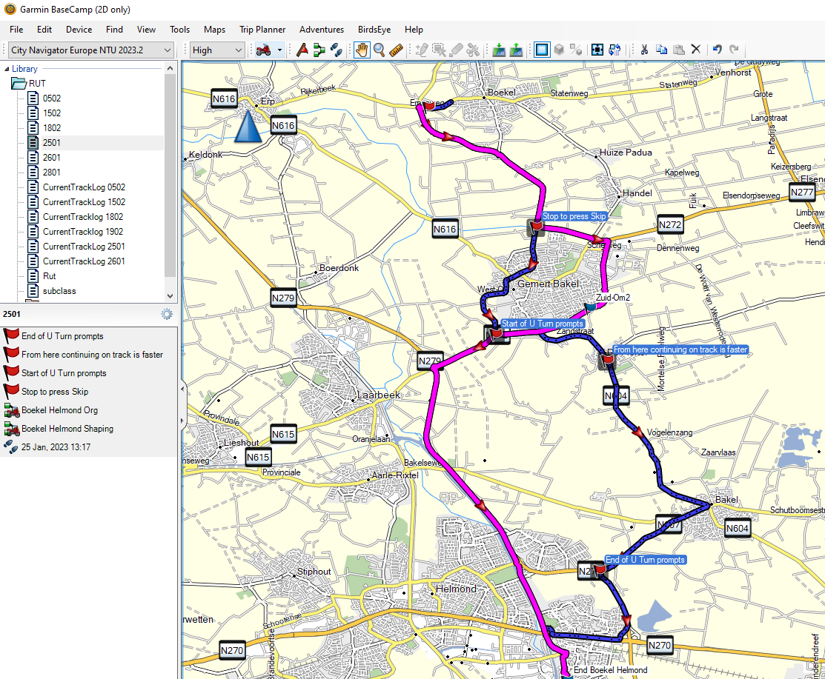
Magenta is the route, Zuid-Om2 is a via point
Blue is the track I would actually drive. At ‘Stop to press Skip’ I would deviate for the 1st time from the route and press Skip. When rejoining the route south of Gemert-Bakel I would not head West, but instead go East following the blue line. Direction De Mortel, Bakel. De Mortel is hidden on by the text ‘From here continuing on track is faster’.
All the way from ‘Start of U Turn prompts’ to ‘End of U Turn prompt’ I would receive U-Turn requests. (Except for the test on 15 feb)

