.trip layout
All integers (unsigned int in C) are MSB (Most Significant Bit)
There is 1 header record, followed by a number of item records
Header record
4 bytes constant ‘TRPL’
4 bytes int File size ’00 00 b9 52’ = 47442. (This is excluding the header length)
1 byte int 0A (Unknown, version ?)
4 byte int ’00 00 00 14’ = 20 Nr of items to follow.
1 byte char ‘09’ Terminator char. This is also used for all items.
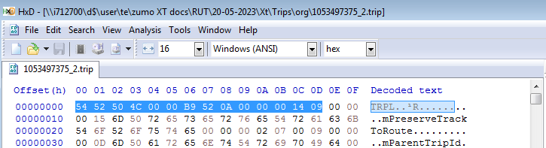

Item Records
An Item record has a different size for each datatype, but they all share the same structure.
4 byte int ’00 00 00 15’ = 21 Size of the key name
N bytes ‘mPreserveTrackToRoute’ Keyname.
4 byte int ’00 00 00 02’ Size of the value. (including the terminator)
1 | Byte Integer
3 | Dword integer
4 | Dword integer
3 and 4 are both Dword integer, maybe one is signed, and the other unsigned?
7 | Bool
14 | String. Strings are 32 bit UTF
128 | List type. Looks like it contains a list of items. This type I did not investigate.  mLocation: via/shaping points?  mAllRoutes: ghost points?
1 byte int ’07’ DataType

N bytes ‘00’ Boolean value for False
1 byte ’09’ Terminator char
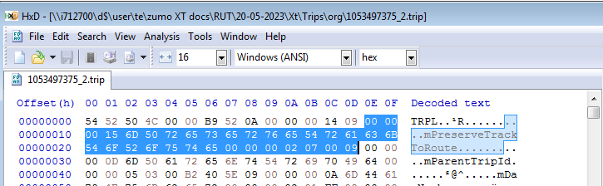

Sample of a string value:
’00 00 00 09’ Length of keyname
‘mFilename’ Keyname
’00 00 00 83’ Length of value
‘0E’ Datatype
’00 80’ Length of string
’30 00 00 00’ first char ‘0’ until ’70 00 00 00’ ‘p’
‘09’ Terminator char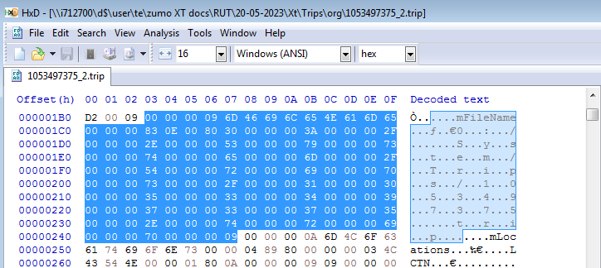

Sample of a list value
’00 00 00 0A’ length of keyname
‘mLocations’ Keyname
’00 00 04 89’ = 1161 Length of value
‘80’ =128 datatype
This list appears to have ‘LCTN’, ‘mAttr’, ‘mIsDFSpoint’ etc. as sub items. Did not look further.

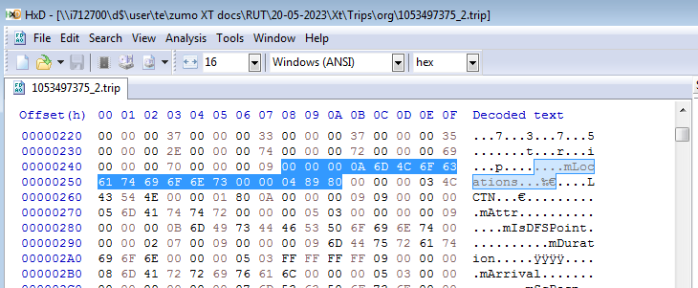
Here’s some Delphi Pascal code that demonstrates how the data can be read/modified. You can use it for documentation purposes.
procedure Swap32(var X);
asm
mov ecx, [eax]
bswap ecx
mov [eax], ecx
end;

procedure TFrmTrip.ReadFile(Sender: TObject);
var Item: integer;
Indx: integer;
KeyLen: DWORD;
KeyName: PAnsiChar;
ValueLen: Dword;
DataType: byte;
ValueData: array of byte;
BytesRead: integer;
ValueBool: Boolean;
ValueByte: byte;
ValueDword: DWORD;

ValueString: string;
PCharLen: smallint;
PCharDword: DWORD;
Terminator: byte;
SaveFilePos: int64;
Msg: string;

const BoolValues: array[False .. True] of string = ('False', 'True');

begin
memo1.Lines.Clear;

if not OpenDialog1.Execute then
exit;
FileMode := fmOpenReadWrite;
AssignFile(F, OpenDialog1.FileName);
Reset(F,1);
BlockRead(F, HeaderRec, SizeOf(HeaderRec));
Swap32(HeaderRec.FileSize);
Swap32(HeaderRec.Items);
Msg := Format('Items expected %d',[HeaderRec.Items]);
Memo1.Lines.Add(Msg);

Item := 0;
while (true) do
begin
inc(Item);
BlockRead(F, KeyLen, SizeOf(KeyLen), BytesRead);
if (BytesRead = 0) then
break;
Swap32(KeyLen);
KeyName := AnsiStrAlloc(KeyLen +1);
FillChar(KeyName^, KeyLen+1, 0);
BlockRead(F, KeyName^, KeyLen, BytesRead);
if (BytesRead = 0) then
break;
BlockRead(F, ValueLen, SizeOf(ValueLen), BytesRead);
if (BytesRead = 0) then
break;
Swap32(ValueLen);
BlockRead(F, DataType, SizeOf(DataType), BytesRead);
if (BytesRead = 0) then
break;

SaveFilePos := FilePos(F);

Msg := format('%d : %s =>', [Item, StrPas(KeyName)]);
case DataType of
1: begin // Byte integer;
BlockRead(F, ValueByte, SizeOf(ValueByte), BytesRead);
if (BytesRead = 0) then
break;
Msg := Msg + Format('%d', [ValueByte]);
end;
3,4:begin // DWORD integer;
BlockRead(F, ValueDword, SizeOf(ValueDword), BytesRead);
if (BytesRead = 0) then
break;
Swap32(ValueDWord);
Msg := Msg + Format('%d', [ValueDWord]);
end;
7: begin // Bool
BlockRead(F, ValueBool, SizeOf(ValueBool), BytesRead);
if (BytesRead = 0) then
break;
if (StrPas(KeyName) = 'mImported') and
(Tbutton(Sender).Tag > -1) and
(Tbutton(Sender).Tag < 2) then
begin
Seek(F, SaveFilePos);
ValueBool := boolean(Tbutton(Sender).Tag);
BlockWrite(F, ValueBool, SizeOf(ValueBool));
end;
Msg := Msg + Format('%s', [BoolValues[ValueBool]]);
end;
14:begin // String
BlockRead(F, PCharLen, SizeOf(PCharLen), BytesRead);
if (BytesRead = 0) then
break;
PCharLen := (Swap(PCharLen) div 4) -1;
ValueString := '';
for Indx := 0 to PcharLen do
begin
BlockRead(F, PCharDword, SizeOf(PCharDword), BytesRead);
if (BytesRead = 0) then
break;
ValueString := ValueString + char(PCharDword);
end;
Msg := Msg + Format('%s', [ValueString]);
end;
else
begin
Msg := Msg + Format('Datatype %d, Len: %d', [datatype, ValueLen]);
end;
end;
StrDispose(KeyName);
Memo1.Lines.Add(Msg);

BlockRead(F, Terminator, SizeOf(Terminator), BytesRead);
if (BytesRead = 0) then
break;

//Failsafe, if we have missed some data
Seek(F, SaveFilePos + ValueLen);
end;

CloseFile(F);
end;

procedure TFrmTrip.Button1Click(Sender: TObject);
begin
ReadFile(Sender);
end;

end.

